## **INE 2 2019-2020**

## **Data Engineer**

## **deep learning project:**

**Generative adversarial networks**

## 

## 

Presented by:

-ESSOULLAMI mostapha

-BOURZIK asmaa

-OUAHID omar

## 

**I)What are Generative Adversarial Networks:**  
Generative Adversarial Networks, or GANs for short, are an approach to generative modeling using deep learning methods, such as convolutional neural networks. Generative modeling is a task in machine learning that involves automatically discovering and learning the regularities or patterns in input data in such a way that the model can be used to generate or output new examples that plausibly could have been drawn from the original dataset.  
GANs are a clever way of training a generative model by framing the problem as a supervised learning problem with two sub-models: the generator model that we train to generate new examples, and the discriminator model that tries to classify examples as either real (from the dataset)or fake (generated). The two models are trained together until the discriminator model is fooled about half the time, meaning the generator model is generating plausible examples.

# a) Generative Adversarial Networks example:

GANs are an exciting and rapidly changing field, delivering on the promise of generative  
models in their ability to generate realistic examples across a range of problem domains, most notably in image-to-image translation tasks such as translating photos of summer to winter or day to night, and in generating photorealistic photos of objects, scenes, and people that even humans cannot tell are fake.

## -**Generate Examples for Image Datasets:**

Generating new plausible samples was the application described in the original paper by Ian Goodfellow, et al. in the 2014 paper “[Generative Adversarial Networks](https://arxiv.org/abs/1406.2661)” where GANs were used to generate new plausible examples for the MNIST handwritten digit dataset, the CIFAR-10 small object photograph dataset, and the Toronto Face Database.

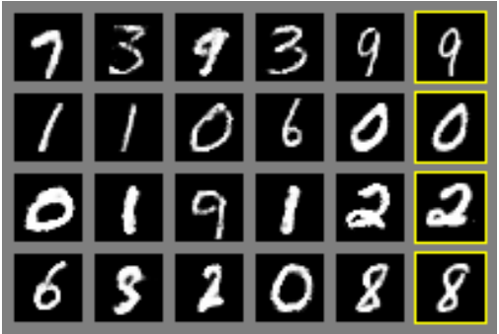

## -**Generate Photographs of Human Faces:**

StyleGAN : introduced by Nvidia researchers in December 2018, is a GAN for producing an unlimited number of portraits of fake human faces.. In February 2019, Uber engineer Phillip Wang used the software to create "thispersondoesnotexist.com", which created a new face on each web page reload. Similarly, two faculty at the University of Washington's Information School used StyleGAN to create "whichfaceisreal.com", which challenged visitors to differentiate between a fake and a real face side-by-side.

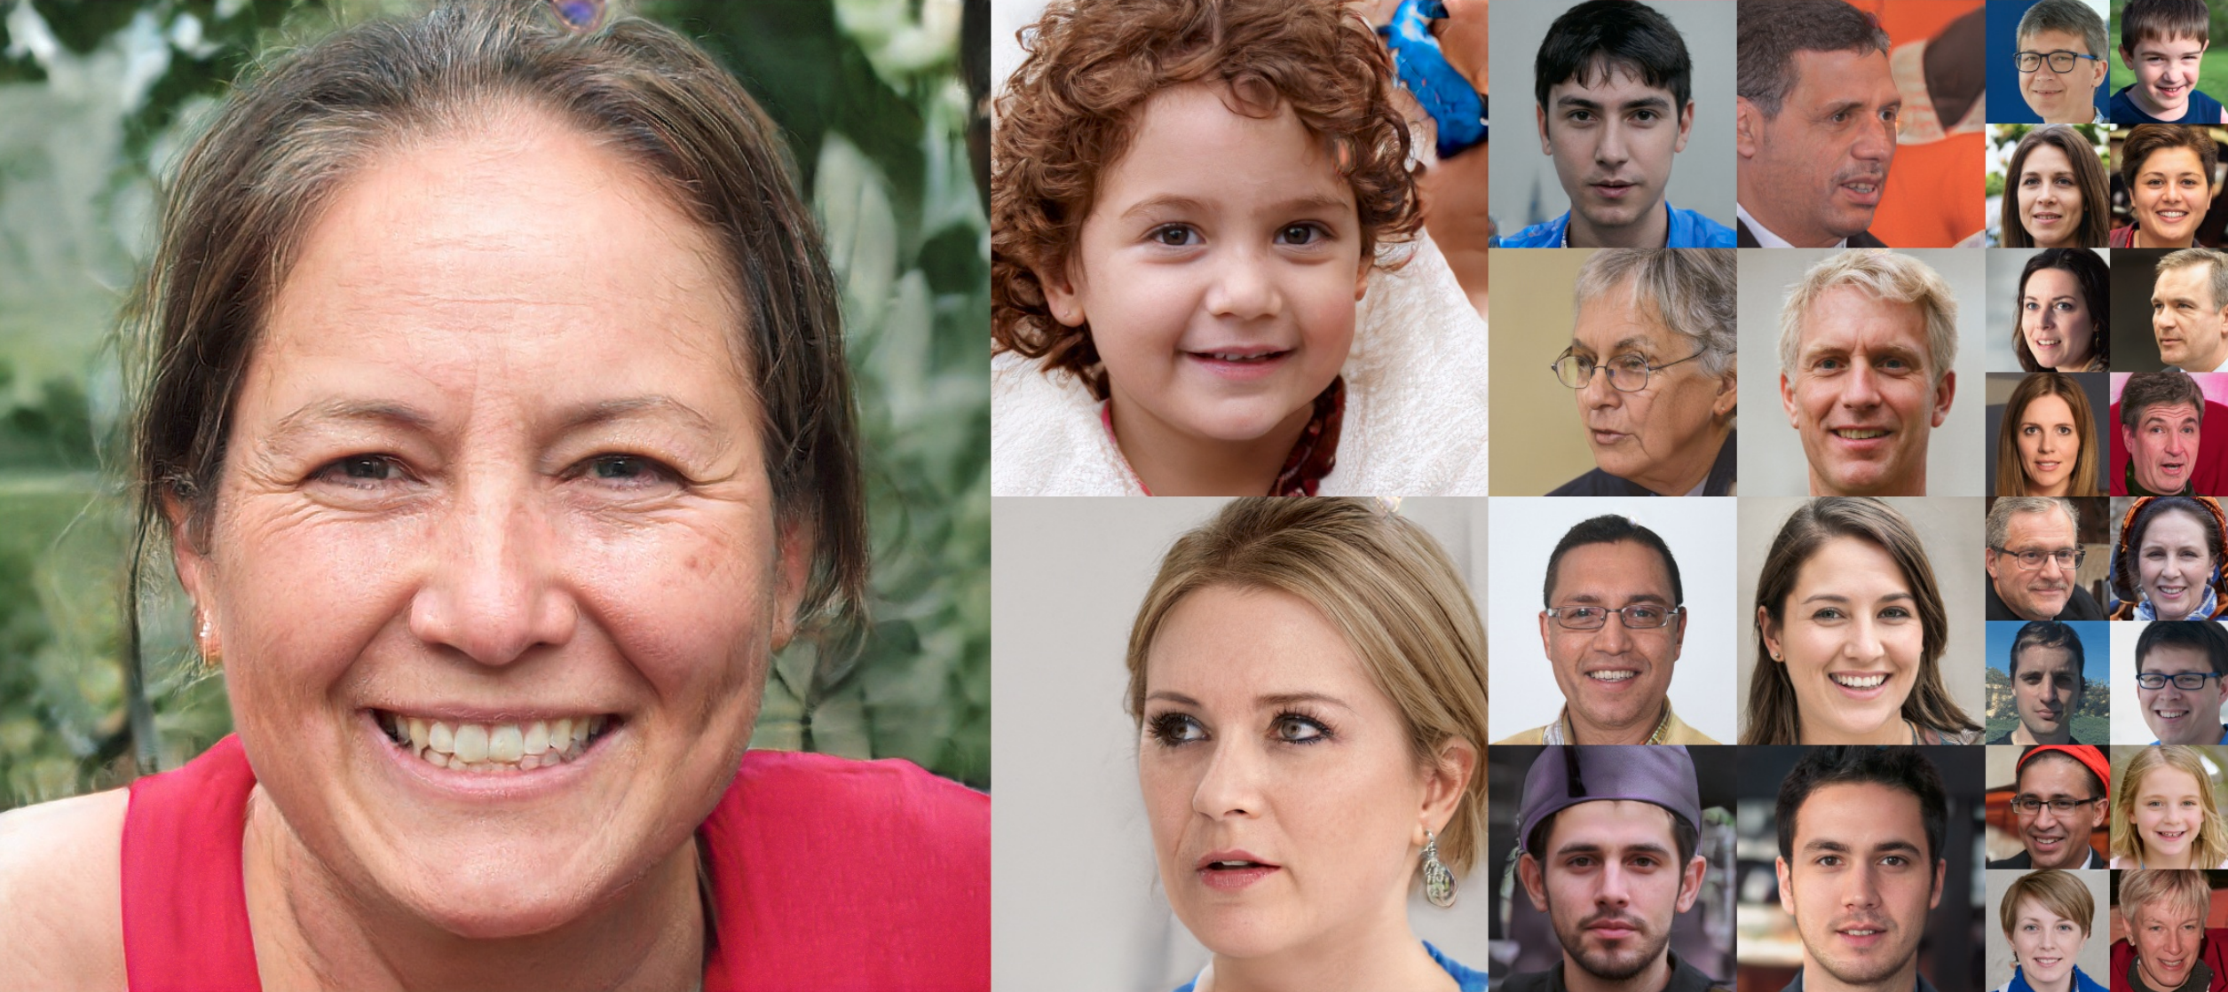

## -**Image-to-Image Translation:**

Image-to-Image translation GANs take an image as input and map it to a generated output image with different properties. For example, you can train an image-to-image GAN to take sketches of handbags and turn them into photorealistic images of handbags

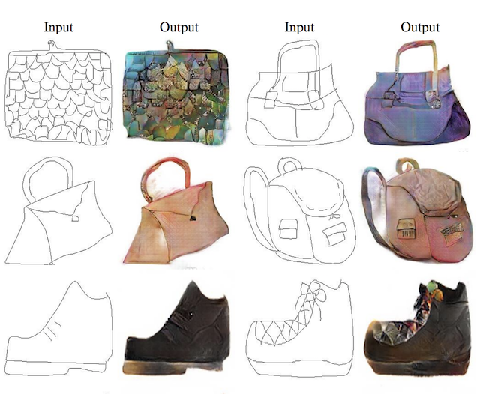

## -**Photos to Emojis :**

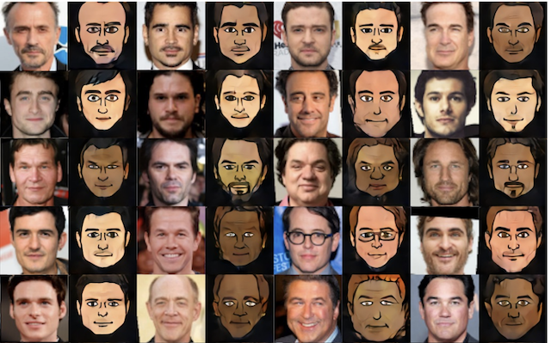

## **-Face Aging:**

use GANs to generate photographs of faces with different apparent ages, from younger to older.

# **II)How Generative Adversarial Networks Work:**

**Principe:**

GANs, a generative AI technique, put 2 networks against each other to generate new content. The algorithm consists of two competing networks: a **generator** and a **discriminator**.

A **generator** is a convolutional neural network (CNN) that learns to create new data resembling the source data it was trained on.

The **discriminator** is another convolutional neural network (CNN) that is trained to differentiate between real and synthetic data.

The generator and the discriminator are trained in alternating cycles such that the generator learns to produce more and more realistic data while the discriminator iteratively gets better at learning to differentiate real data from the newly created data.

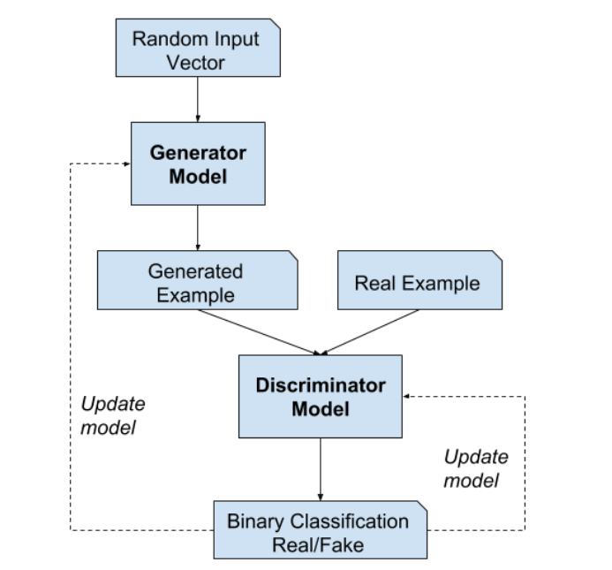

**DISCRIMINATOR:**

The discriminator in a GAN is simply a classifier. It tries to distinguish real data from the data created by the generator. It could use any network architecture appropriate to the type of data it's classifying.

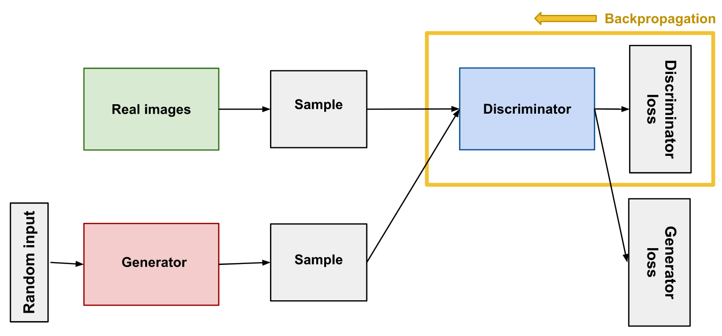

## **Discriminator Training:**

The discriminator's training data comes from two sources:

* **Real data** instances, such as real pictures of people. The discriminator uses these instances as positive examples during training.
* **Fake data** instances created by the generator. The discriminator uses these instances as negative examples during training.

During discriminator training the generator does not train. Its weights remain constant while it produces examples for the discriminator to train on.

During discriminator training:

1. The discriminator classifies both real data and fake data from the generator.
2. The discriminator loss penalizes the discriminator for misclassifying a real instance as fake or a fake instance as real.
3. The discriminator updates its weights through backpropagation from the discriminator loss through the discriminator network.

# **The Generator:**

The generator part of a GAN learns to create fake data by incorporating feedback from the discriminator. It learns to make the discriminator classify its output as real.

Generator training requires tighter integration between the generator and the discriminator than discriminator training requires.

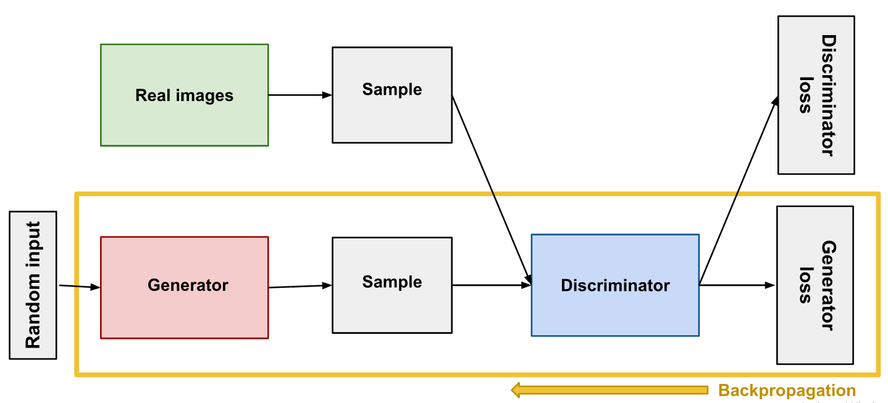

## **Using the Discriminator to Train the Generator**

To train a neural net, we alter the net's weights to reduce the error or loss of its output. In our GAN, however, the generator is not directly connected to the loss that we're trying to affect. The generator feeds into the discriminator net, and the discriminator produces the output we're trying to affect. The generator loss penalizes the generator for producing a sample that the discriminator network classifies as fake.

This extra chunk of network must be included in backpropagation. Backpropagation adjusts each weight in the right direction by calculating the weight's impact on the output. But the impact of a generator weight depends on the impact of the discriminator weights it feeds into. So backpropagation starts at the output and flows back through the discriminator into the generator.

At the same time, we don't want the discriminator to change during generator training. Trying to hit a moving target would make a hard problem even harder for the generator.

So we train the generator with the following procedure:

1. Sample random noise.
2. Produce generator output from sampled random noise.
3. Get discriminator "Real" or "Fake" classification for generator output.
4. Calculate loss from discriminator classification.
5. Backpropagate through both the discriminator and generator to obtain gradients.
6. Use gradients to change only the generator weights.

# **GAN Training:**

The generator and the discriminator have different training processes. So how do we train the GAN as a whole?

GAN training proceeds in alternating periods:

1. The discriminator trains for one or more epochs.
2. The generator trains for one or more epochs.
3. Repeat steps 1 and 2 to continue to train the generator and discriminator networks.

We keep the generator constant during the discriminator training phase. As discriminator training tries to figure out how to distinguish real data from fake, it has to learn how to recognize the generator's flaws.

Similarly, we keep the discriminator constant during the generator training phase. Otherwise the generator would be trying to hit a moving target and might never converge.

if you can't train a classifier to tell the difference between real and generated data even for the initial random generator output, you can't get the GAN training started.

## **Convergence:**

As the generator improves with training, the discriminator performance gets worse because the discriminator can't easily tell the difference between real and fake. If the generator succeeds perfectly, then the discriminator has a 50% accuracy. In effect, the discriminator flips a coin to make its prediction.

This progression poses a problem for convergence of the GAN as a whole: the discriminator feedback gets less meaningful over time. If the GAN continues training past the point when the discriminator is giving completely random feedback, then the generator starts to train on junk feedback, and its own quality may collapse.

# **Loss Functions:**

GANs try to replicate a probability distribution. They should therefore use loss functions that reflect the distance between the distribution of the data generated by the GAN and the distribution of the real data.

How do you capture the difference between two distributions in GAN loss functions? This question is an area of active research, and many approaches have been proposed. We'll address only one common GAN loss functions here:

* **minimax loss**: The loss function used in the [paper that introduced GANs](https://arxiv.org/abs/1406.2661).

## **Minimax Loss**

In the paper that introduced GANs, the generator tries to minimize the following function while the discriminator tries to maximize it:



In this function:

* D(x) is the discriminator's estimate of the probability that real data instance x is real.
* Ex is the expected value over all real data instances.
* G(z) is the generator's output when given noise z.
* D(G(z)) is the discriminator's estimate of the probability that a fake instance is real.
* Ez is the expected value over all random inputs to the generator (in effect, the expected value over all generated fake instances G(z)).

The generator can't directly affect the log(D(x)) term in the function, so, for the generator, minimizing the loss is equivalent to minimizing log(1 - D(G(z))).

**III) How to Implement the GAN Training Algorithm:**  
The GAN training algorithm involves training both the discriminator and the generator model  
in parallel. The algorithm is summarized in the figure below, taken from the original 2014 paper  
by Goodfellow, et al. titled Generative Adversarial Networks.

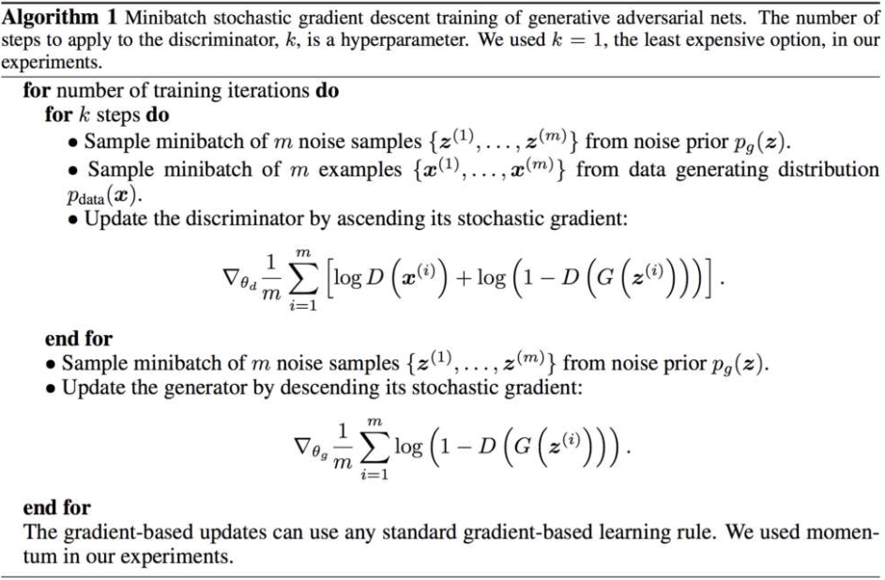

# **GAN Problems:**

GANs have a number of common failure modes. All of these common problems are areas of active research. While none of these problems have been completely solved, we'll mention some things that people have tried.

## **Vanishing Gradients**

[Research](https://arxiv.org/pdf/1701.04862.pdf) has suggested that if your discriminator is too good, then generator training can fail due to [vanishing gradients](https://wikipedia.org/wiki/Vanishing_gradient_problem). In effect, an optimal discriminator doesn't provide enough information for the generator to make progress.

### Attempts to Remedy :

* **Wasserstein loss**: The [Wasserstein loss](https://developers.google.com/machine-learning/gan/loss) is designed to prevent vanishing gradients even when you train the discriminator to optimality.
* **Modified minimax loss**: The [original GAN paper](http://papers.nips.cc/paper/5423-generative-adversarial-nets.pdf) proposed a [modification to minimax loss](https://developers.google.com/machine-learning/gan/loss) to deal with vanishing gradients. 

## **Mode Collapse**

Usually you want your GAN to produce a wide variety of outputs. You want, for example, a different face for every random input to your face generator.

However, if a generator produces an especially plausible output, the generator may learn to produce only that output. In fact, the generator is always trying to find the one output that seems most plausible to the discriminator.

If the generator starts producing the same output (or a small set of outputs) over and over again, the discriminator's best strategy is to learn to always reject that output. But if the next generation of discriminator gets stuck in a local minimum and doesn't find the best strategy, then it's too easy for the next generator iteration to find the most plausible output for the current discriminator.

Each iteration of generator over-optimizes for a particular discriminator, and the discriminator never manages to learn its way out of the trap. As a result the generators rotate through a small set of output types. This form of GAN failure is called **mode collapse**.

### Attempts to Remedy:

The following approaches try to force the generator to broaden its scope by preventing it from optimizing for a single fixed discriminator:

* **Wasserstein loss**: The [Wasserstein loss](https://developers.google.com/machine-learning/gan/loss) alleviates mode collapse by letting you train the discriminator to optimality without worrying about vanishing gradients. If the discriminator doesn't get stuck in local minima, it learns to reject the outputs that the generator stabilizes on. So the generator has to try something new.
* **Unrolled GANs**: [Unrolled GANs](https://arxiv.org/pdf/1611.02163.pdf) use a generator loss function that incorporates not only the current discriminator's classifications, but also the outputs of future discriminator versions. So the generator can't over-optimize for a single discriminator.

## **Failure to Converge:**

the model parameters oscillate, destabilize and never converge, GANs frequently fail to converge

### Attempts to Remedy

Researchers have tried to use various forms of regularization to improve GAN convergence, including:

* **Adding noise to discriminator inputs**: See, for example, [Toward Principled Methods for Training Generative Adversarial Networks](https://arxiv.org/pdf/1701.04862.pdf).
* **Penalizing discriminator weights**: See, for example, [Stabilizing Training of Generative Adversarial Networks through Regularization](https://arxiv.org/pdf/1705.09367.pdf).

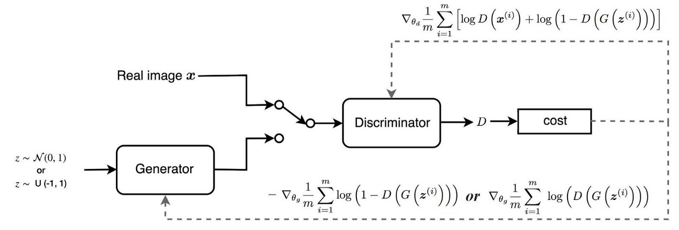

**IV) Application:**

**Simple 1D GAN:**

GANs are comprised of both generator and discriminator models. The generator is responsible for generating new samples from the domain, and the discriminator is responsible for classifying whether samples are real or fake (generated). Importantly, the performance of the discriminator model is used to update both the model weights of the discriminator itself and the generator model. This means that the generator never actually sees examples from the domain and is adapted based on how well the discriminator performs. This is a complex type of model both to understand and to train.

To better understand the nature of GAN models and how they can be trained we will develop a model from scratch for a very simple task.

A simple task that provides a good context for developing a simple GAN from scratch is a one-dimensional function since both real and generated samples can be plotted and visually inspected to get an idea of what has been learned. A simple function also does not require sophisticated neural network models, meaning the specific generator and discriminator models used on the architecture can be easily understood.

## Selecting a One-Dimensional Function

We want a function that we can easily understand and plot. This will help in both setting an expectation of what the model should be generating and in using a visual inspection of generated examples to get an idea of their quality.

We will choose x² function now we can generate random samples or points from this function, this can be achieved by generating random values between -0.5 and 0.5 and calculating the associated output value. Repeating this many times will give a sample of points from the function, e.g. “real samples.”. Plotting these samples using a scatter plot will show the u-shape plot

CODE:

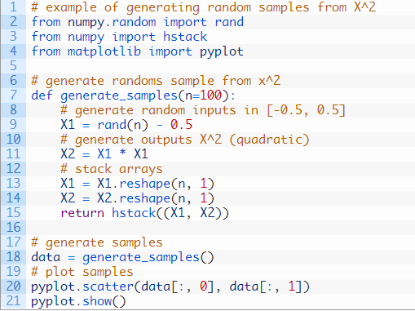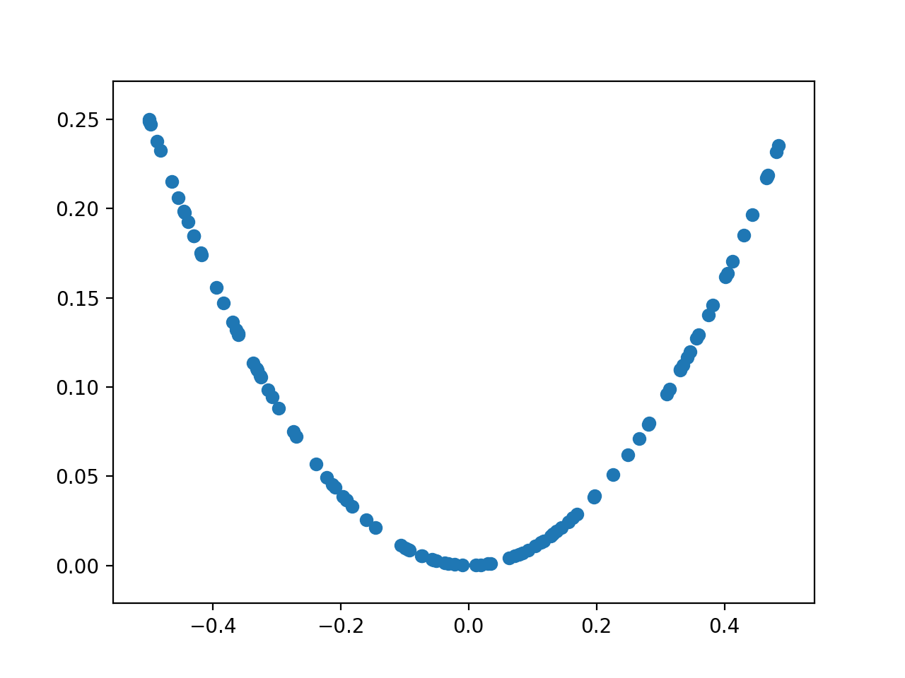

We can use this function as a starting point for generating real samples for our discriminator function. Specifically, a sample is comprised of a vector with two elements (x, x²)

We can also imagine how a generator model could generate new samples that we can plot and compare to the expected u-shape of the x² function. Specifically, a generator would output a vector with two elements: one for the input and one for the output of our one-dimensional function.

## **Define a Discriminator Model**

The next step is to define the discriminator model.

The model must take a sample from our problem, a vector with two elements, and output a classification prediction as to whether the sample is real or fake.

This is a binary classification problem.

* **Inputs**: Sample with two real values (x, x²).
* **Outputs**: likelihood the sample is real (or fake).

The problem is very simple, meaning that we don’t need a complex neural network to model it.

The discriminator model will have one hidden layer with 25 nodes and we will use the [ReLU activation function](https://machinelearningmastery.com/rectified-linear-activation-function-for-deep-learning-neural-networks/). The output layer will have one node for the binary classification using the sigmoid activation function.

The model will minimize the binary cross entropy loss function

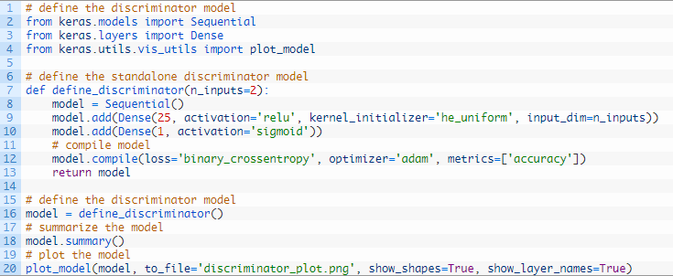

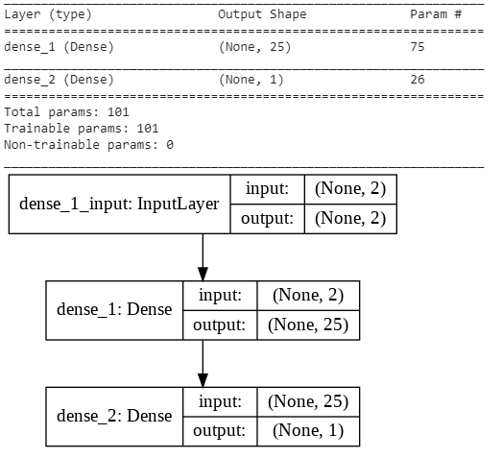

## **Define a Generator Model:**

The next step is to define the generator model.

The generator model takes as input a point from the latent space and generates a new sample, e.g. a vector with both the input and output elements of our function, e.g. x and x².

the latent space has no meaning until the generator model starts assigning meaning to points in the space as it learns. After training, points in the latent space will correspond to points in the output space, e.g. in the space of generated samples.

We will define a small latent space of five dimensions and use the standard approach in the GAN literature of using a Gaussian distribution for each variable in the latent space. We will generate new inputs by drawing random numbers from a standard Gaussian distribution.

* **Inputs**: five-element vector of Gaussian random numbers.
* **Outputs**: Two-element vector representing a generated sample for our function (x and x²).

The generator model will be small like the discriminator model.

It will have a single hidden layer with 15 nodes and will use the [ReLU activation function](https://machinelearningmastery.com/rectified-linear-activation-function-for-deep-learning-neural-networks/) and the He weight initialization. The output layer will have two nodes for the two elements in a generated vector and will use a linear activation function.

A linear activation function is used because we know we want the generator to output a vector of real values and the scale will be [-0.5, 0.5] for the first element and about [0.0, 0.25] for the second element.

The model is not compiled. The reason for this is that the generator model is not fit directly.

The define_generator() function below defines and returns the generator model.

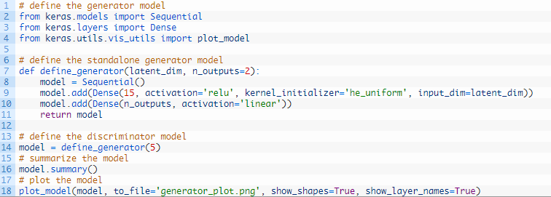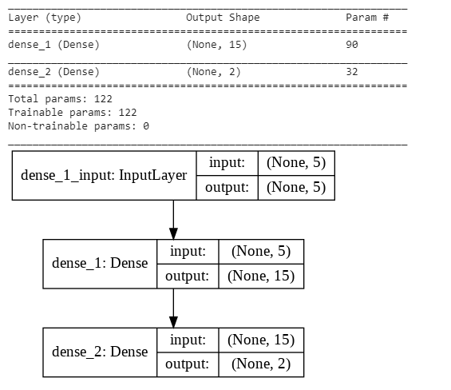

This model cannot do much at the moment. Nevertheless, we can demonstrate how to use it to generate samples. This is not needed, but some of these elements may be useful later.

The first step is to generate new points in the latent space. We can achieve this by calling the [randn() NumPy function](https://docs.scipy.org/doc/numpy/reference/generated/numpy.random.randn.html) for generating arrays of random numbers.

The array of random numbers can then be reshaped into samples: that is n rows with five elements per row. The generate_latent_points() function implements this and generates the desired number of points in the latent space that can be used as input to the generator model.

Next, we can use the generated points as input the generator model to generate new samples, then plot the samples.

The *generate_fake_samples()* function below implements this, where the defined generator and size of the latent space are passed as arguments, along with the number of points for the model to generate.

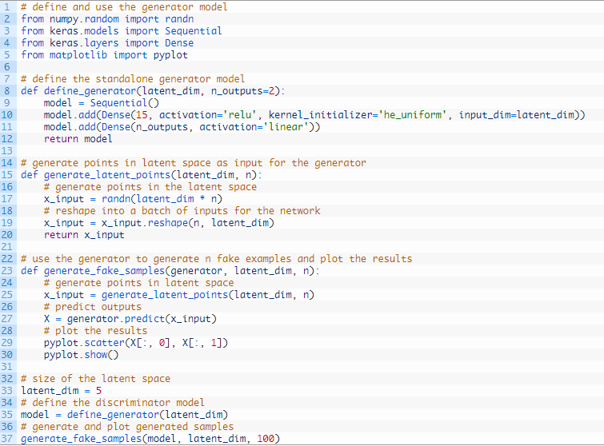

Running the example generates 100 random points from the latent space, uses this as input to the generator and generates 100 fake samples from our one-dimensional function domain.

As the generator has not been trained, the generated points are complete rubbish, as we expect, but we can imagine that as the model is trained, these points will slowly begin to resemble the target function and its u-shape.

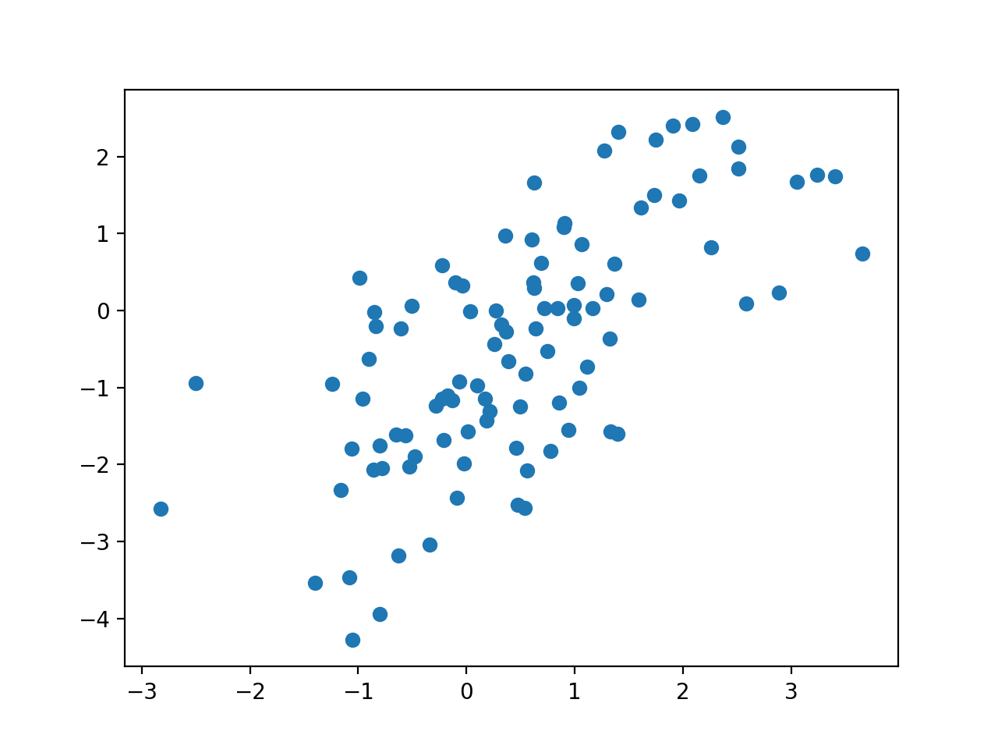

## **Training the Generator Model:**

The weights in the generator model are updated based on the performance of the discriminator model.

When the discriminator is good at detecting fake samples, the generator is updated more, and when the discriminator model is relatively poor or confused when detecting fake samples, the generator model is updated less.

This defines the zero-sum or adversarial relationship between these two models.

A GAN model can be defined that stacks the generator and discriminator such that the generator receives as input random points in the latent space, generates samples that are fed into the discriminator model directly, classified, and the output of this larger model can be used to update the model weights of the generator.

To be clear, we are not talking about a new third model, just a logical third model that uses the already-defined layers and weights from the standalone generator and discriminator models.

Only the discriminator is concerned with distinguishing between real and fake examples; therefore, the discriminator model can be trained in a standalone manner on examples of each.

The generator model is only concerned with the discriminator’s performance on fake examples. Therefore, we will mark all of the layers in the discriminator as not trainable when it is part of the GAN model so that they can not be updated and overtrained on fake examples.

When training the generator via this subsumed GAN model, there is one more important change. We want the discriminator to think that the samples output by the generator are real, not fake. Therefore, when the generator is trained as part of the GAN model, we will mark the generated samples as real (class 1).

We can imagine that the discriminator will then classify the generated samples as not real (class 0) or a low probability of being real (0.3 or 0.5). The backpropagation process used to update the model weights will see this as a large error and will update the model weights (i.e. only the weights in the generator) to correct for this error, in turn making the generator better at generating plausible fake samples.

Let’s make this concrete.

* **Inputs**: Point in latent space, e.g. a five-element vector of Gaussian random numbers.
* **Outputs**: likelihood the sample is real (or fake).

The define_gan() function below takes as arguments the already-defined generator and discriminator models and creates the new logical third model subsuming these two models. The weights in the discriminator are marked as not trainable, which only affects the weights as seen by the GAN model and not the standalone discriminator model.

The GAN model then uses the same binary cross entropy loss function as the discriminator and the efficient [Adam version of stochastic gradient descent](https://machinelearningmastery.com/adam-optimization-algorithm-for-deep-learning/).

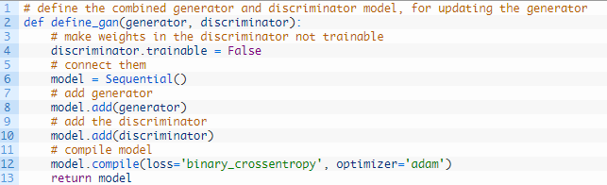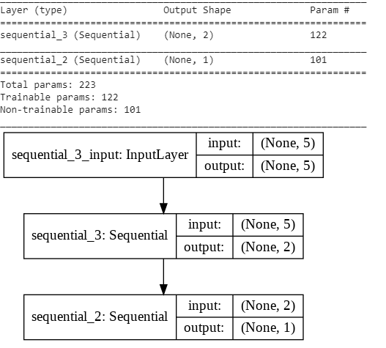

The complete train function for updating the discriminator model and the generator (via the composite model) is listed below.

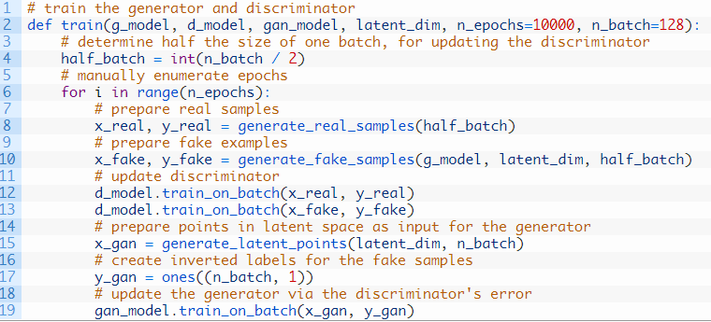

## **Evaluating the Performance of the GAN:**

we will use the generator to generate new samples and inspect them relative to real samples from the domain.

First, we can use the generate_real_samples() function to generate real examples. Creating a scatter plot of these examples will create the familiar u-shape of our target function.

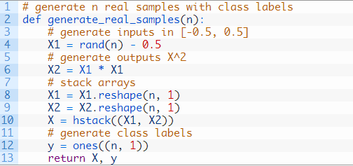

Next, we can use the generator model to generate the same number of fake samples.

This requires first generating the same number of points in the latent space via the *generate_latent_points()* function developed in the generator section above. These can then be passed to the generator model and used to generate samples that can also be plotted on the same scatter plot.

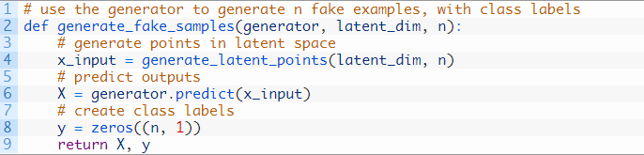

Having both samples plotted on the same graph allows them to be directly compared to see if the same input and output domain are covered and whether the expected shape of the target function has been appropriately captured, at least subjectively.

The *summarize_performance()* function below can be called any time during training to create a scatter plot of real and generated points to get an idea of the current capability of the generator model.

We may also be interested in the performance of the discriminator model at the same time.

Specifically, we are interested to know how well the discriminator model can correctly identify real and fake samples. A good generator model should make the discriminator model confused, resulting in a classification accuracy closer to 50% on real and fake examples.

the *summarize_performance()* function will also take the discriminator and current epoch number as arguments and report the accuracy on the sample of real and fake examples.

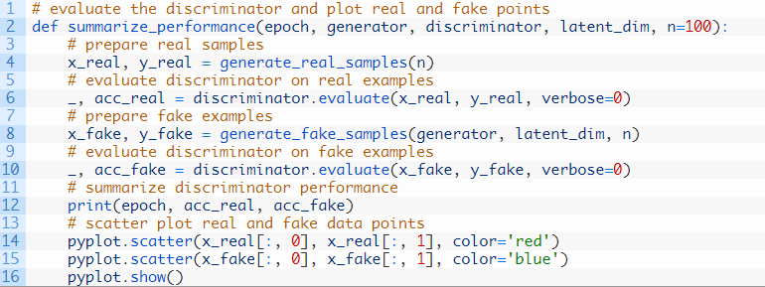

This function can then be called periodically during training.

For example, if we choose to train the models for 10,000 iterations, it may be interesting to check-in on the performance of the model every 2,000 iterations.

We can achieve this by parameterizing the frequency of the check-in via *n_eval* argument, and calling the *summarize_performance()* function from the *train()* function after the appropriate number of iterations.

The updated version of the *train()* function with this change is listed below.

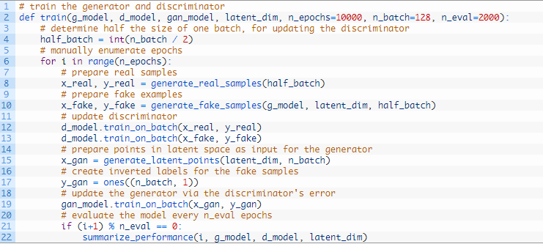

## **Complete Example of Training the GAN:**

We now have everything we need to train and evaluate a GAN on our chosen one-dimensional function.

The complete example is listed below.

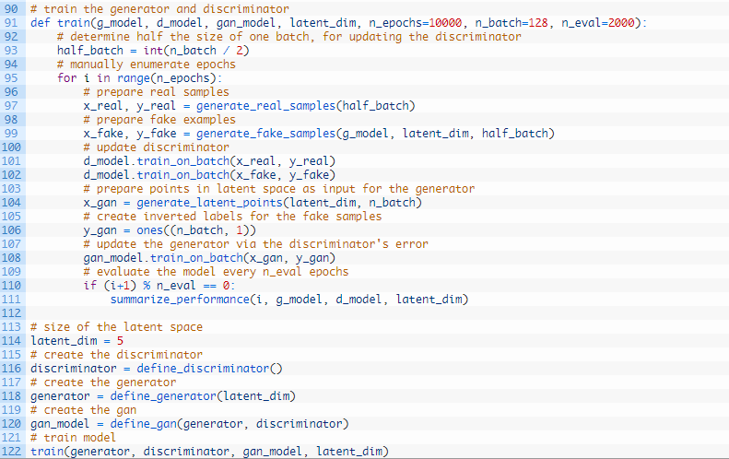

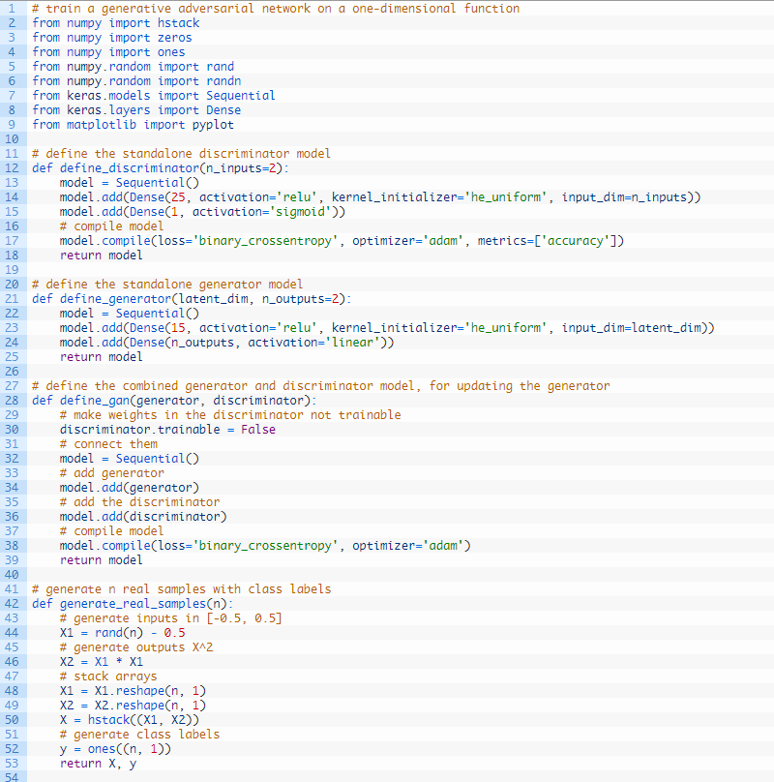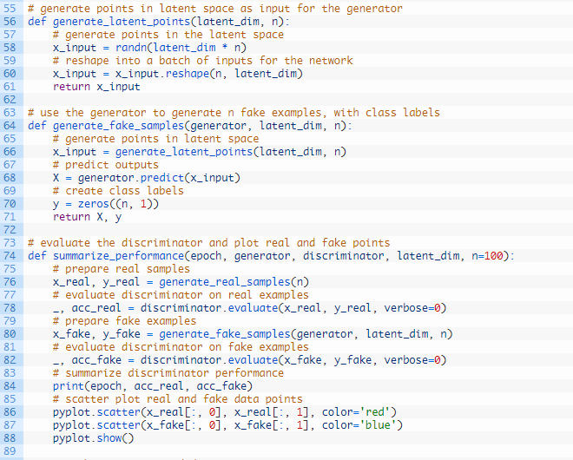

Running the example reports model performance every 2,000 training iterations (batches) and creates a plot.

The first plot is created after 2,000 iterations and shows real (red) vs. fake (blue) samples.

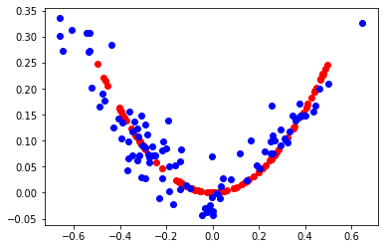

The second plot shows real (red) vs. fake (blue) after 6,000 iterations.

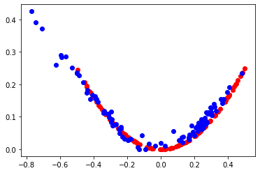

The third plot shows real (red) vs. fake (blue) after 10,000 iterations.Here we can see that the generator model does a reasonable job of generating plausible samples.

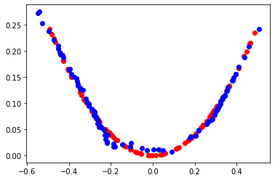

**Application 2: MNIST**

Developing a GAN for generating images requires both a discriminator convolutional neural network model for classifying whether a given image is real or generated and a generator model that uses inverse convolutional layers to transform an input to a full two-dimensional image of pixel values.

It can be challenging to understand both how GANs work and how deep convolutional neural network models can be trained in a GAN architecture for image generation. A good starting point for beginners is to practice developing and using GANs on standard image datasets used in the field of computer vision, such as the MNIST handwritten digit dataset. Using small and well-understood datasets means that smaller models can be developed and trained quickly, allowing the focus to be put on the model architecture and image generation process itself.

## MNIST Handwritten Digit Dataset

The [MNIST dataset](https://en.wikipedia.org/wiki/MNIST_database) is an acronym that stands for the Modified National Institute of Standards and Technology dataset.

It is a dataset of 70,000 small square 28×28 pixel grayscale images of handwritten single digits between 0 and 9.

Keras provides access to the MNIST dataset via the [mnist.load_dataset() function](https://keras.io/datasets/" \l "mnist-database-of-handwritten-digits). It returns two tuples, one with the input and output elements for the standard training dataset, and another with the input and output elements for the standard test dataset.

The images are grayscale with a black background (0 pixel value) and the handwritten digits in white (pixel values near 255). This means if the images were plotted, they would be mostly black with a white digit in the middle.

We can plot some of the images from the training dataset using the matplotlib library using the [imshow() function](https://matplotlib.org/api/_as_gen/matplotlib.pyplot.imshow.html) and specify the color map via the ‘cmap‘ argument as ‘gray‘ to show the pixel values correctly, the images are easier to review when we reverse the colors and plot the background as white and the handwritten digits in black.

They are easier to view as most of the image is now white with the area of interest in black. This can be achieved using a reverse grayscale color map. The example below plots the first 25 images from the training dataset in a 5 by 5 square:

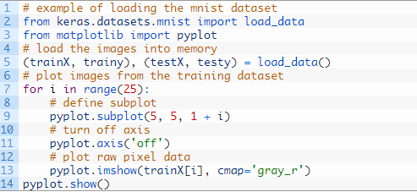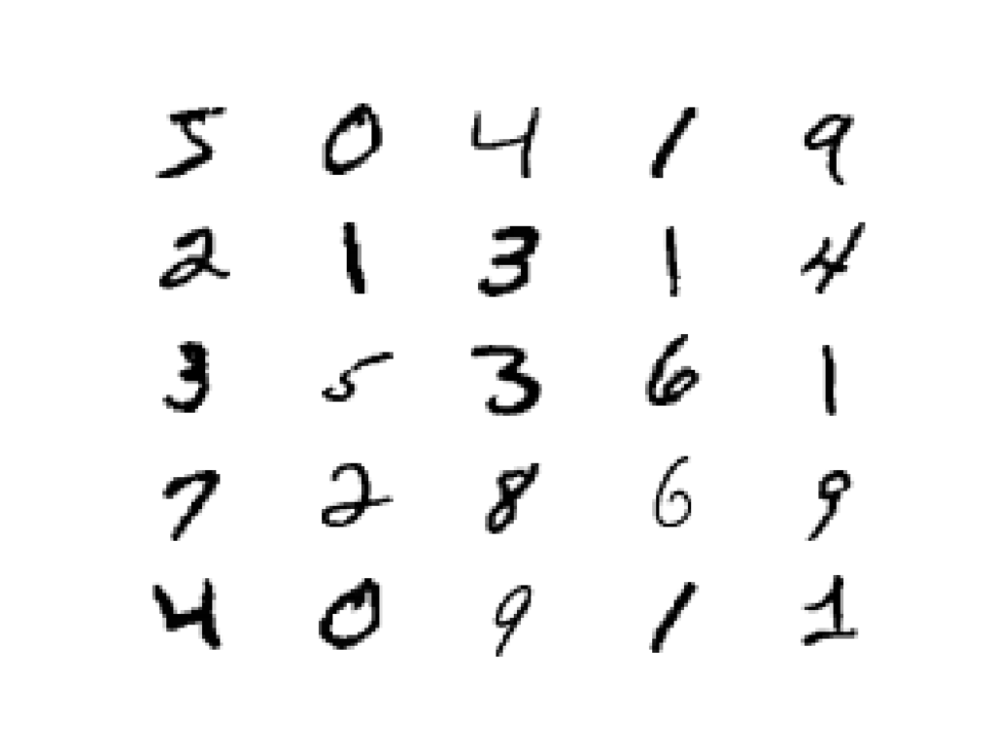

We will use the images in the training dataset as the basis for training a Generative Adversarial Network.

Specifically, the generator model will learn how to generate new plausible handwritten digits between 0 and 9, using a discriminator that will try to distinguish between real images from the MNIST training dataset and new images output by the generator model.

## **Define and Train the Discriminator Model**

The first step is to define the discriminator model.

The model must take a sample image from our dataset as input and output a classification prediction as to whether the sample is real or fake.

This is a binary classification problem:

* **Inputs**: Image with one channel and 28×28 pixels in size.
* **Outputs**: Binary classification, likelihood the sample is real (or fake).

The discriminator model has two [convolutional layers](https://machinelearningmastery.com/convolutional-layers-for-deep-learning-neural-networks/) with 64 filters each, a small kernel size of 3, and larger than normal stride of 2. The model has no pooling layers and a single node in the output layer with the sigmoid activation function to predict whether the input sample is real or fake. The model is trained to minimize the [binary cross entropy loss function](https://machinelearningmastery.com/how-to-choose-loss-functions-when-training-deep-learning-neural-networks/), appropriate for binary classification.

The function define_discriminator() below defines the discriminator model and parametrizes the size of the input image.

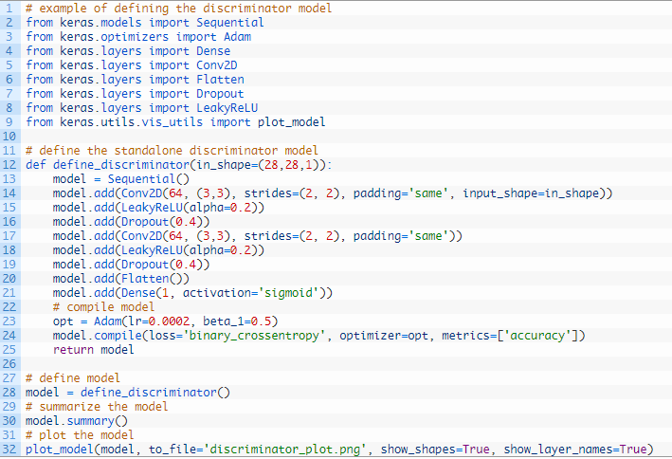

Running the example first summarizes the model architecture, showing the input and output from each layer.

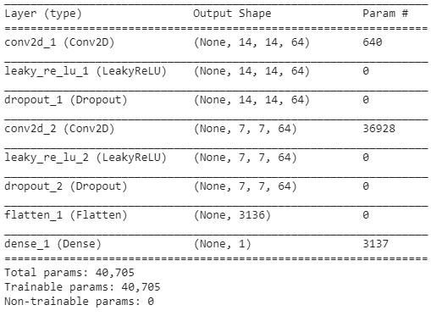

We can see that the aggressive [2×2 stride acts to down-sample the input image](https://machinelearningmastery.com/padding-and-stride-for-convolutional-neural-networks/), first from 28×28 to 14×14, then to 7×7, before the model makes an output prediction.

This pattern is by design as we do not use pooling layers and use the large stride as achieve a similar downsampling effect. We will see a similar pattern, but in reverse, in the generator model in the next section.

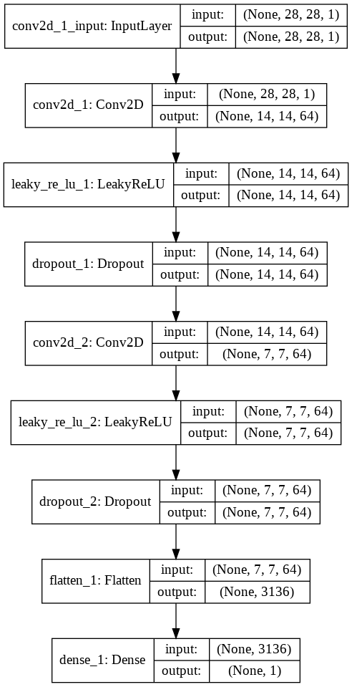

## **Define and Use the Generator Model**

The generator model is responsible for creating new, fake but plausible images of handwritten digits.

It does this by taking a point from the latent space as input and outputting a square grayscale image.

The latent space is an arbitrarily defined vector space of [Gaussian-distributed values](https://machinelearningmastery.com/statistical-data-distributions/), e.g. 100 dimensions. It has no meaning, but by drawing points from this space randomly and providing them to the generator model during training, the generator model will assign meaning to the latent points and, in turn, the latent space, until, at the end of training, the latent vector space represents a compressed representation of the output space, MNIST images, that only the generator knows how to turn into plausible MNIST images.

* **Inputs**: Point in latent space, e.g. a 100 element vector of Gaussian random numbers.
* **Outputs**: Two-dimensional square grayscale image of 28×28 pixels with pixel values in [0,1].

Note: we don’t have to use a 100 element vector as input; it is a round number and widely used, but I would expect that 10, 50, or 500 would work just as well.

Developing a generator model requires that we transform a vector from the latent space with, 100 dimensions to a 2D array with 28×28 or 784 values.

There are a number of ways to achieve this but there is one approach that has proven effective at deep convolutional generative adversarial networks. It involves two main elements.

The first is a Dense layer as the first hidden layer that has enough nodes to represent a low-resolution version of the output image. Specifically, an image half the size (one quarter the area) of the output image would be 14×14 or 196 nodes, and an image one quarter the size (one eighth the area) would be 7×7 or 49 nodes.

We don’t just want one low-resolution version of the image; we want many parallel versions or interpretations of the input. This is a [pattern in convolutional neural networks](https://machinelearningmastery.com/review-of-architectural-innovations-for-convolutional-neural-networks-for-image-classification/) where we have many parallel filters resulting in multiple parallel activation maps, called feature maps, with different interpretations of the input. We want the same thing in reverse: many parallel versions of our output with different learned features that can be collapsed in the output layer into a final image. The model needs space to invent, create, or generate.

Therefore, the first hidden layer, the Dense, needs enough nodes for multiple low-resolution versions of our output image, such as 128.

The activations from these nodes can then be reshaped into something image-like to pass into a convolutional layer, such as 128 different 7×7 feature maps.

The next major architectural innovation involves upsampling the low-resolution image to a higher resolution version of the image.

There are two common ways to do this upsampling process, sometimes called deconvolution.

One way is to use an UpSampling2D layer (like a reverse pooling layer) followed by a normal Conv2D layer. The other and perhaps more modern way is to combine these two operations into a single layer, called a Conv2DTranspose. We will use this latter approach for our generator.

The Conv2DTranspose layer can be configured with a stride of (2×2) that will quadruple the area of the input feature maps (double their width and height dimensions). It is also good practice to use a kernel size that is a factor of the stride (e.g. double) to [avoid a checkerboard pattern](https://distill.pub/2016/deconv-checkerboard/) that can be observed when upsampling.

This can be repeated to arrive at our 28×28 output image.

Again, we will use the LeakyReLU with a default slope of 0.2, reported as a best practice when training GAN models.

The output layer of the model is a Conv2D with one filter and a kernel size of 7×7 and [‘same’ padding](https://machinelearningmastery.com/padding-and-stride-for-convolutional-neural-networks/), designed to create a single feature map and preserve its dimensions at 28×28 pixels. A sigmoid activation is used to ensure output values are in the desired range of [0,1].

The define_generator() function below implements this and defines the generator model.

**Note**: the generator model is not compiled and does not specify a loss function or optimization algorithm. This is because the generator is not trained directly.

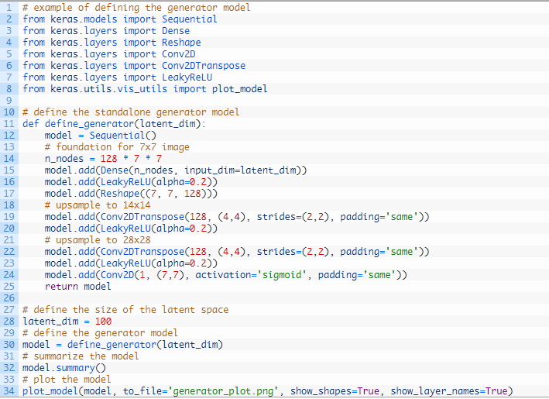

Running the example summarizes the layers of the model and their output shape.

We can see that, as designed, the first hidden layer has 6,272 parameters or 128 * 7 * 7, the activations of which are reshaped into 128 7×7 feature maps. The feature maps are then upscaled via the two *Conv2DTranspose* layers to the desired output shape of 28×28, until the output layer, where a single activation map is output.

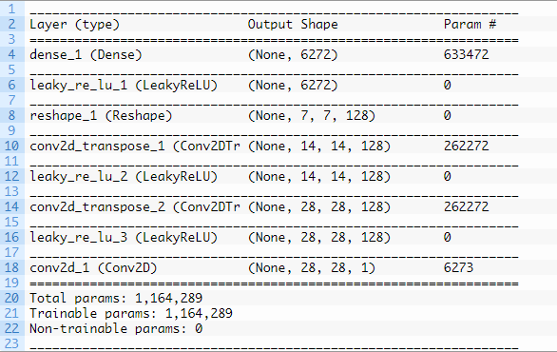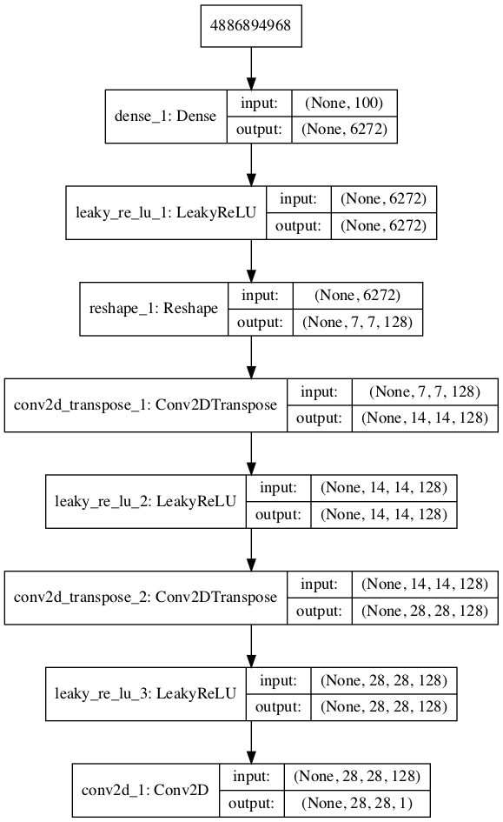

## **Evaluate GAN Model Performance**

Generally, there are no objective ways to evaluate the performance of a GAN model.

We cannot calculate this objective error score for generated images. It might be possible in the case of MNIST images because the images are so well constrained, but in general, it is not possible (yet).

Instead, images must be subjectively evaluated for quality by a human operator. This means that we cannot know when to stop training without looking at examples of generated images. In turn, the adversarial nature of the training process means that the generator is changing after every batch, meaning that once “good enough” images can be generated, the subjective quality of the images may then begin to vary, improve, or even degrade with subsequent updates.

There are three ways to handle this complex training situation.

1. Periodically evaluate the classification accuracy of the discriminator on real and fake images.
2. Periodically generate many images and save them to file for subjective review.
3. Periodically save the generator model.

All three of these actions can be performed at the same time for a given training epoch, such as every five or 10 training epochs. The result will be a saved generator model for which we have a way of subjectively assessing the quality of its output and objectively knowing how well the discriminator was fooled at the time the model was saved.

Training the GAN over many epochs, such as hundreds or thousands of epochs, will result in many snapshots of the model that can be inspected and from which specific outputs and models can be cherry-picked for later use.

We can define a function called summarize_performance() function that will summarize the performance of the discriminator model. It does this by retrieving a sample of real MNIST images, as well as generating the same number of fake MNIST images with the generator model, then evaluating the classification accuracy of the discriminator model on each sample and reporting these scores.

This function can be called from the *train()* function based on the current epoch number, such as every 10 epochs.

Next, we can use the *summarize_performance()* function to both save the model and to create and save a plot generated examples.

The generator model can be saved by calling the *save()* function on the generator model and providing a unique filename based on the training epoch number.

We can develop a function to create a plot of the generated samples.

As we are evaluating the discriminator on 100 generated MNIST images, we can plot all 100 images as a 10 by 10 grid. The *save_plot()* function below implements this, again saving the resulting plot with a unique filename based on the epoch number.

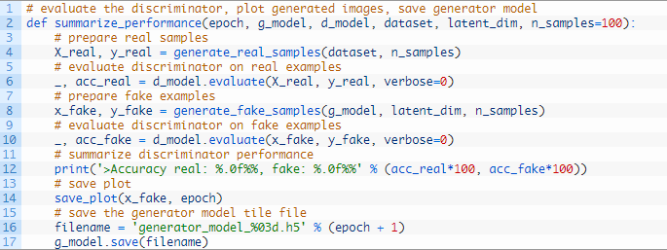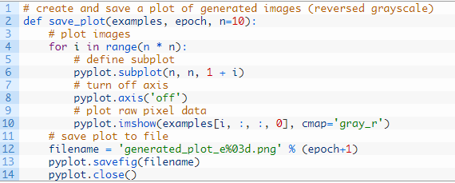

## Complete Example of GAN for MNIST

We now have everything we need to train and evaluate a GAN on the MNIST handwritten digit dataset.

The complete example is listed below.

Note: this example can run on a CPU but may take a number of hours. The example can run on a GPU, such as the Amazon EC2 p3 instances, and will complete in a few minutes.

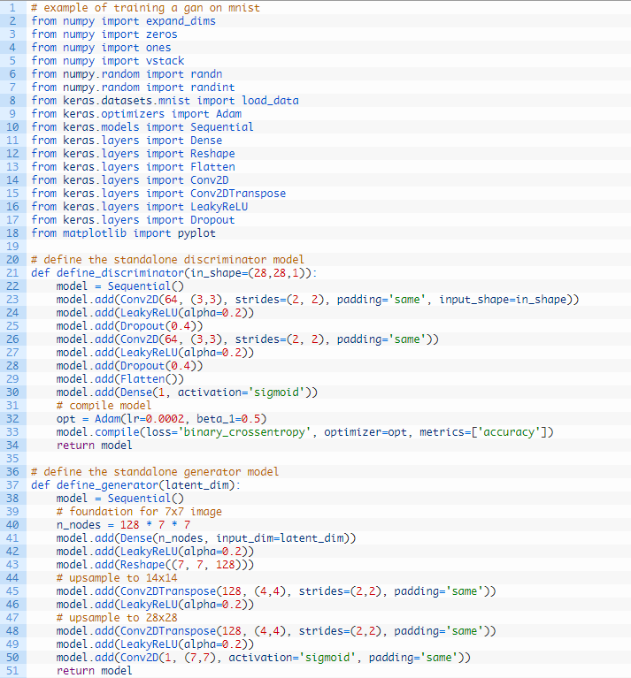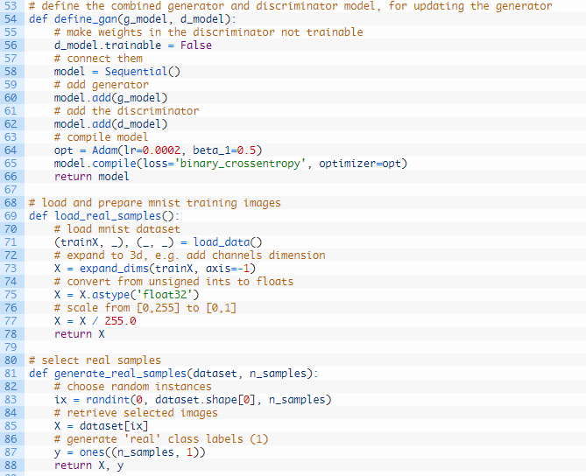

The model performance is reported every batch, including the loss of both the discriminative (d) and generative (g) models.

The generator is evaluated every 20 epochs, resulting in 10 evaluations, 10 plots of generated images, and 10 saved models.

